**Semester 1 (Unit 3) Examination, 2019**

**Question/Answer Booklet**

**MATHEMATICS APPLICATIONS**

**Section Two: Calculator-assumed**

Student Name/Number: ______________________________________________

Teacher Name: ______________________________________________

**Time allowed for this section**

Reading time before commencing work: ten minutes

Working time for this section: one hundred minutes

**Materials required/recommended for this section**

**To be provided by the supervisor:** This Question/Answer Booklet

Formula Sheet (retained from Section One)

**To be provided by the candidate:**

Standard items: pens (blue/black preferred), pencils (including coloured), sharpener,

correction fluid/tape, eraser, ruler, highlighters

Special items: drawing instruments, templates, notes on 2 unfolded sheets of A4 paper, and up to three calculators approved for use in the WACE examinations

**Important note to candidates**

No other items may be taken into the examination room. It is **your** responsibility to ensure that you do not have any unauthorised notes or other items of a non-personal nature in the examination room. If you have any unauthorised material with you, hand it to the supervisor **before** reading any further.

**Structure of this paper**

|  |  |  |  |  |  |
| --- | --- | --- | --- | --- | --- |
| Section | Number of questions available | Number of questions to be answered | Working time (minutes) | Marks available | Percentage of exam |
| Section One: Calculator-free | 6 | 6 | 50 | 50 | 35 |
| Section Two: Calculator-assumed | 12 | 12 | 100 | 100 | 65 |
|  | | | | | 100 |

**Instructions to candidates**

1. The rules for the conduct of School exams are detailed in the *College assessment policy*. Sitting this examination implies that you agree to abide by these rules.
2. Write your answers in this Question/Answer Booklet.

3. You must be careful to confine your responses to the specific questions asked and to follow any instructions that are specific to a particular question.

1. Supplementary pages for the use of planning/continuing your answer to a question have been provided at the end of this Question/Answer booklet. If you use these pages to continue an answer, indicate at the original answer where the answer is continued, i.e. give the page number.
2. Show all working clearly**.** Your working should be in sufficient detail to allow your answers to be checked readily and for marks to be awarded for reasoning. Incorrect answers given without supporting reasoning cannot be allocated any marks. For any question or part question worth more than two marks, valid working or justification is required to receive full marks. If you repeat any question, ensure that you cancel the answer you do not wish to have marked.
3. It is recommended that you do not use pencil, except in diagrams.
4. The Formula Sheet is not to be handed in with your Question/Answer Booklet.

**Section Two: Calculator-assumed 65% (100 Marks)**

This section has **12** questions. Answer **all** questions. Write your answers in the spaces provided.

Supplementary pages for the use of planning/continuing your answer to a question have been provided at the end of this Question/Answer booklet. If you use these pages to continue an answer, indicate at the original answer where the answer is continued, i.e. give the page number.

Suggested working time: 100minutes.

**Question 7 (7 marks)**

1. A geometric sequence has and , determine the first four terms.

(2 marks)

1. A sequence is given by  and , determine the first four terms.

(2 marks)

1. Annie started an exercise routine by walking 3 km on the first day and then increased by “*d* ” km every day. The distance walked can be modelled by the recursive equation

, , where  is the distance walked each day.

1. Complete the table of values below. (2 marks)

|  |  |  |  |  |  |  |
| --- | --- | --- | --- | --- | --- | --- |
| *n* | 1 | 2 | 3 | 4 | 5 | 6 |
|  |  |  |  |  |  |  |

1. Hence, state whether this sequence is an AP, GP or neither. (1 mark)

**Question 8 (10 marks)**

The table below shows the population data for Australia and Western Australia for 2008 and 2018

|  |  |  |  |
| --- | --- | --- | --- |
| **Population statistics for Australia and Western Australia 2008 and 2018** | | | |
|  |  | June 2008 | June 2018 |
| Australia | Males | 10 572 045 | 12 397 898 |
| Females | 10 677 154 |  |
| Total |  | 24 992 369 |
| Western Australia | Males | 1 094 894 | 1 298 288 |
| Females | 803 832 | 1 297 589 |
| Total | 2 171 100 | 2 595 877 |

(a) Complete the table by filling in the missing two numbers (1 mark)

(b) One of the numbers for Western Australia has been entered incorrectly. Identify the incorrect number, explain why you think the number is the incorrect one and state the correct number below. (2 marks)

(c) The incomplete table below shows percentages (to two decimal places) of males and females in Australia and Western Australia at June 2008 and June 2018.

|  |  |  |  |
| --- | --- | --- | --- |
| **Population percentages for Australia and Western Australia 2008 and 2018** | | | |
|  |  | Jun-08 | Jun-18 |
| Australia | Males | 49.75% |  |
| Females |  |  |
| Western Australia | Males |  | 50.01% |
| Females |  |  |

1. Show how the value 50.01% was calculated. (2 marks)
2. Complete the table. (2 marks)

(d) Use the data to determine one association between the variables. Describe and interpret the association. (2 marks)

(e) Explain why converting the original data to percentages was helpful. (1 mark)

**Question 9 (8 marks)**

The network of paths linking different classrooms at a school is displayed below:

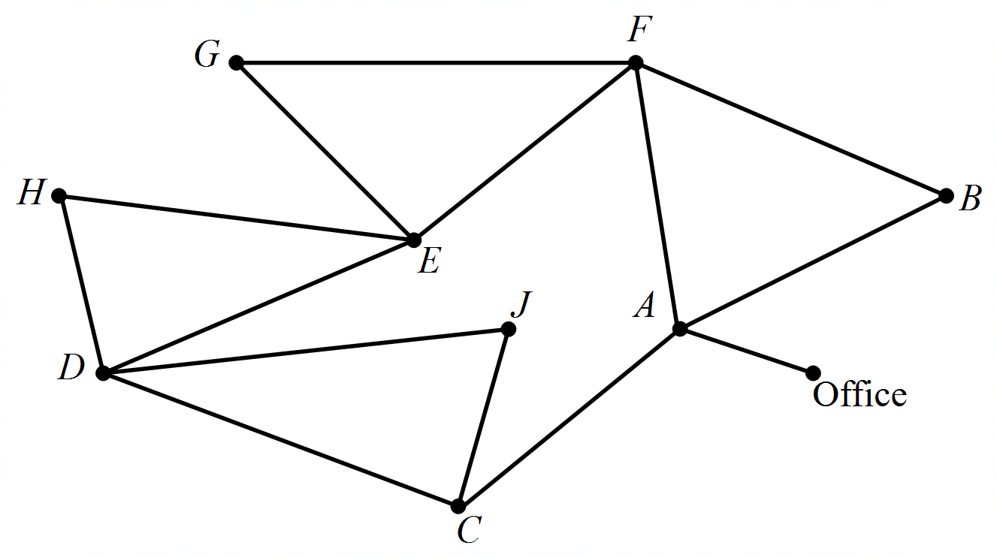

(a) A Semi-Eulerian trail starting at the office must finish at what vertex? State the trail.

(3 marks)

(b) There is a power outage at the school and in order to get the daily notices out, they

have decided to send a student from the front office to each of the classes.

1. Show a possible route that will have the student delivering the message to each class, starting at the office, without repeating any of the classrooms.

(2 marks)

1. What is the best way to describe this route? (1 mark)

(c) The student realises they need to have a toilet break on the way. The toilets are

located on the path connecting Classroom F and E.

Is it still possible to plan a route visiting each classroom once only? Justify your answer. (2 marks)

**Question 10 (10 marks)**

The following adjacency matrix, *M*, lists the number of road connections between four towns.

(a) Use the adjacency matrix given, to draw the corresponding graph. (2 marks)

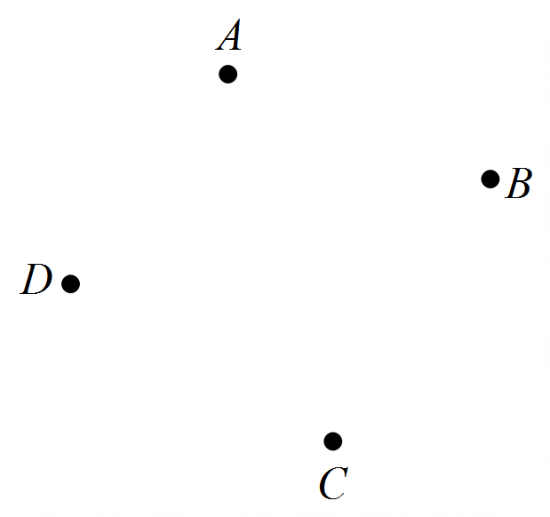



(b)

1. Calculate  (2 marks)
2. Explain the significance of the elements in that are zero (2 marks)

(c) (i) Is the graph drawn in part (a) planar? (1 mark)

(ii) Verify your response from part (c)(i), using Euler’s formula (3 marks)

**Question 11 (16 marks)**

A currency exchange trader is interested in the relationship between the exchange rate between the Australian dollar and the US dollar, against the Trade weighted index (TWI) of the Australian Dollar. The table below shows the average monthly AUS/USD exchange rate alongside the average monthly TWI for a period of 12 months.

|  |  |
| --- | --- |
| AUS/USD exchange rate | TWI of the $A |
| 0.7946 | 65.3 |
| 0.7933 | 64.4 |
| 0.7876 | 64 |
| 0.7508 | 63.1 |
| 0.7465 | 62.1 |
| 0.7465 | 62.4 |
| 0.7436 | 63.3 |
| 0.7213 | 62.4 |
| 0.72 | 61.9 |
| 0.7108 | 61.6 |
| 0.7279 | 63.1 |
| 0.7189 | 62.2 |

(a) State the explanatory variable (1 mark)

(b) Complete the scatterplot below by plotting the two missing data points and labelling the axes clearly. (3 marks)

(c) (i) Calculate the correlation coefficient for the data. (1 mark)

(ii) Comment briefly on your answer to part (c) with reference to the scatter plot in part (b). (2 marks)

(d) (i) Determine the equation of the least-squares line that models these data. State the gradient of the line correct to one decimal place. (2 marks)

(ii) Draw the line determined in part d(i) on the scatter plot in part (b). Clearly show two calculated points of the line. (2 marks)

(e) Calculate the coefficient of determination and interpret it. (2 marks)

(f) Estimate the average monthly TWI of the 13th month, given that the AUD/USD exchange is 0.732 an comment on the reliability of this estimate. (3 marks)

**Question 12 (6 marks)**

The graph below shows time, in minutes, taken to travel on roads connecting seven different towns. A motorist wishes to drive from Airton to Evergreen.

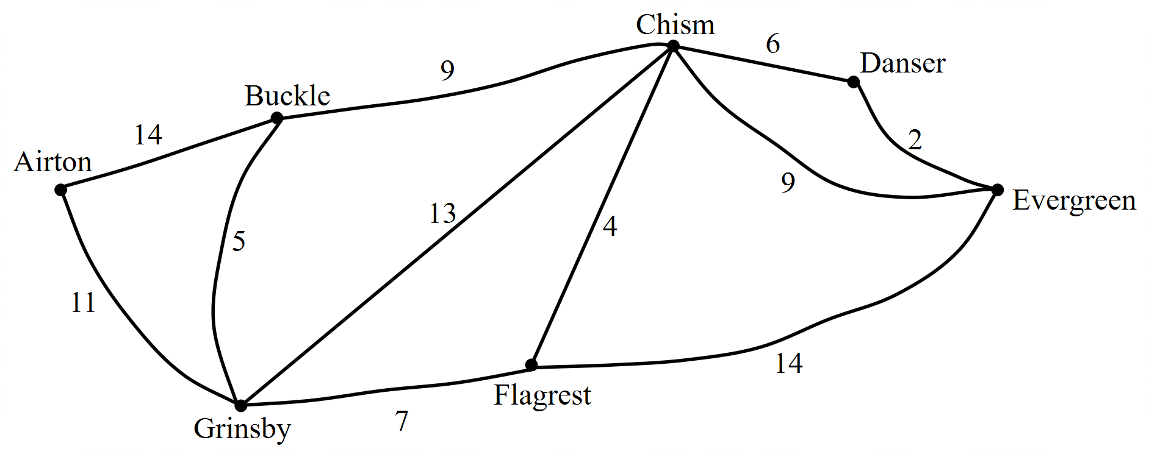

(a) State the shortest route and travel time, clearly showing the route on the graph. (3 marks)

(b) There is an issue with drainage which results in a road closure between *Grinsby* and

*Flagrest*. How does this effect the chosen route in part (a)? (3 marks)

**Question 13 (5 marks)**

In their retirement, George and Gita bought a rural property in the country. They decided to put some alpacas on the property and started by purchasing 30 alpacas. George has found that the approximate number of alpacas at the start of the n*th* year can be modelled by

, 

(a) Explain the significance of the 0.8 value. (1 mark)

(b) How many additional alpacas are bought at the start of each year? Show relevant calculations to support your answer. (2 marks)

1. George and Gita would like to maintain a constant number of 20 alpacas at the start of each year. The number of alpacas can now be represented by .

Determine the value of *k*. (2 marks)

**Question 14 (7 marks)**

Frank and Amy are researching buying car. The car they want retails at a recommended price of $45 000 when new, which is outside their price range. They decide to buy a one year old car of the same make and model.

They believe that a fair price to pay for the vehicle depends on the number of kilometres on the odometer according to the following prediction formula.

Predicted fair value , where is the number of kilometres (in thousands) on the car’s odometer and the predicted price, is in thousands of dollars.

The coefficient of determination is given as 0.8577.

|  |  |  |  |  |  |  |  |  |  |  |
| --- | --- | --- | --- | --- | --- | --- | --- | --- | --- | --- |
| Kilometers (in 000’s) | 5 | 7.5 | 10 | 12.5 | 15 | 17.5 | 20 | 25 | 30 | 35 |
| Actual resale value (A) | 33.5 | 33 | 30.5 | 31.5 | 32 | 29.9 | 30.5 | 28.8 | 29 | 27 |
| Predicted resale value (P) | 31.55 | 31.325 | 31.1 | 30.875 | 30.65 | 30.425 | **A** | 29.75 | **B** | 28.85 |
| Residuals | 1.95 | 1.675 | -0.6 | 0.625 | 1.35 | -0.525 | 0.3 | -0.95 | **C** | **D** |

(a) What percentage of the variation in the resale value can be explained by the variation in the number of kilometres? (1 mark)

(b) Predict the resale values **A** and **B**. (1 mark)

(c) Determine the residuals **C** and **D**. (2 marks)

(d) Complete the scatter plot of the residuals on the axes below. (2 marks)

Kilometres(*k*)

(e) What feature of the residual plot suggests that a linear model is an appropriate representation of the relationship between resale value and kilometres? (1 mark)

**Question 15 (9 marks)**

A group of seven friends had the option of two separate parties on the weekend, one in the city and one at the beach. As the parties were a large distance away from each other, they were unable to attend both. To keep each other updated they decided to share photos with their friends who were not at the party they were attending.

Bec and Charlie went into the city and both shared their photos with Alice & Emma. Dean shared his with Bec, whilst Gillian shared hers with Emma and Frank.

(a) (i) Display this information as a bipartite graph, clearly stating which friends went

to each party. (3 marks)

(ii) How many more edges would be required to make it a complete bipartite graph? (1 mark)

(b) (i) Draw the complete graph, , using the vertices given below: (2 marks)

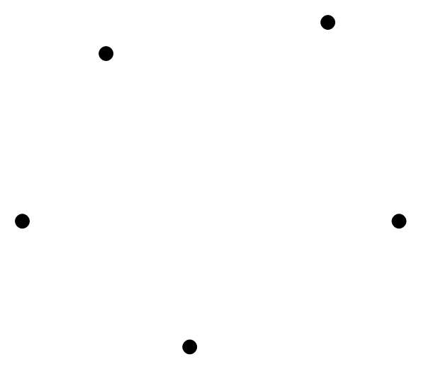

(ii) Explain why this graph is not planar. (1 mark)

(c) A recent rugby tournament was formed as a round robin competition where every

team played every other team. This involved 78 games.

How many teams competed at the tournament? (2 marks)

**Question 16 (8 marks)**

The population of a newly established town was recorded at the end of the first four years and tabulated below.

|  |  |  |  |  |
| --- | --- | --- | --- | --- |
| Year | 2010 | 2011 | 2012 | 2013 |
| Year number, n | 1 | 2 | 3 | 4 |
| Population | 500 | 575 | 646 | 714 |

(a) Explain why this set of data does not follow an arithmetic nor a geometric sequence using relevant calculations. (3 marks)

(b) A recurrence equation models this data, , .

What do the following represent? Give your answer in the context of the question.

(i) 0.95 (1 mark)

(ii) 100 (1 mark)

1. Use the difference equation to find the population of this town at the end of 2018.

(1 mark)

(d) What will be the maximum population of this town? Show your working out algebraically. (2 marks)

**Question 17 (6 marks)**

From 30 November 2017, a driver of a motor vehicle must pass a bicycle travelling in the same direction at a safe distance, being:

* 1 metre on roads where the posted speed limit is 60 km/h or less;
* 1.5 metres on roads where the posted speed limit is more than 60km/h.

A local cycling club wants to investigate the awareness of the new law.

(a) Describe two ways by which students could collect relevant data about bicycle law awareness. (2 marks)

(b) Use the data in the table below to determine and to describe one association between the variables. Explain your reasoning. (2 marks)

**Bicycle accident/injury statistics 2012 to 2018**

|  |  |  |  |
| --- | --- | --- | --- |
|  | Fatalities | Serious injuries | Minor injuries |
| 2012 | 3 | 78 | 516 |
| 2013 | 5 | 73 | 484 |
| 2014 | 4 | 64 | 494 |
| 2015 | 4 | 74 | 505 |
| 2016 | 5 | 52 | 448 |
| 2017 | 6 | 57 | 462 |
| 2018 | 3 | 52 | 437 |

(c) What additional data would be helpful in determining a reliable trend. Explain how this would help. (2 marks)

**Question 18 (8 marks)**

The kitchen in the house which Julie recently bought needs a “facelift”.

Her mother, Susan, gave Julie an interest free loan to renovate the kitchen.

Julie repays the loan at the end of each month. She repays $50 in the first month, $55 the second month and the repayments continue to rise by $5 per month until the loan is repaid.

(a) Write a recursive rule for the monthly repayments made. (2 marks)

(b) Julie’s final repayment is $200. Determine the number of months it takes Julie to pay off the loan. Justify your answer algebraically. (3 marks)

(c) Find the total amount loaned to Julie. (1 mark)

(d) (i) How long would Julie take to repay the loan if she repaid $35 the first month,

$45 the second month, $55 in the third month and so on. (1 mark)

(ii) State the final repayment. (1 mark)

**End of Questions**

Additional working space

Question number: __________________

Additional working space

Question number: __________________

**Acknowledgements**

Data for Question 8 was sourced from the website for the Australian Bureau of Statistics.

© MAWA, 2018

This examination is Copyright but may be freely used within the school that purchases this licence.

* The items that are contained in this examination are to be used solely in the school for which they are purchased.
* They are not to be shared in any manner with a school which has not purchased their own licence.
* The items and the solutions/marking keys are to be kept confidentially and not copied or made available to anyone who is not a teacher at the school. Teachers may give feedback to students in the form of showing them how the work is marked but students are not to retain a copy of the paper or marking guide until the agreed release date stipulated in the purchasing agreement/licence.

*Published by The Mathematical Association of WA*

*12 Cobbler Place, MIRRABOOKA 6…*